1.flow with salesforce as a service provider?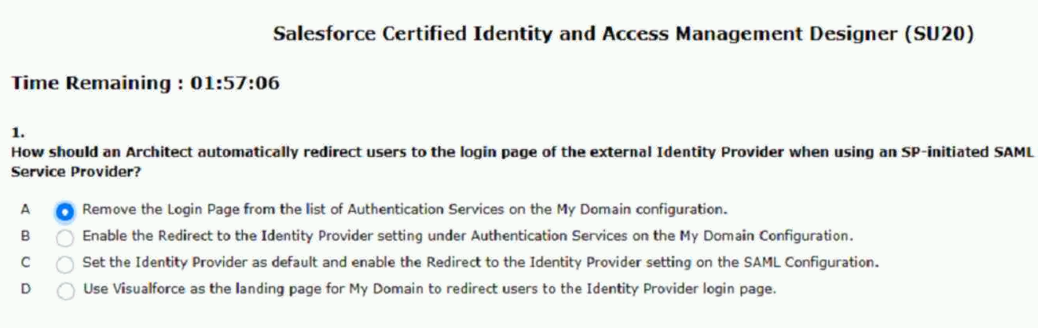

2.based single sign-on for authentication.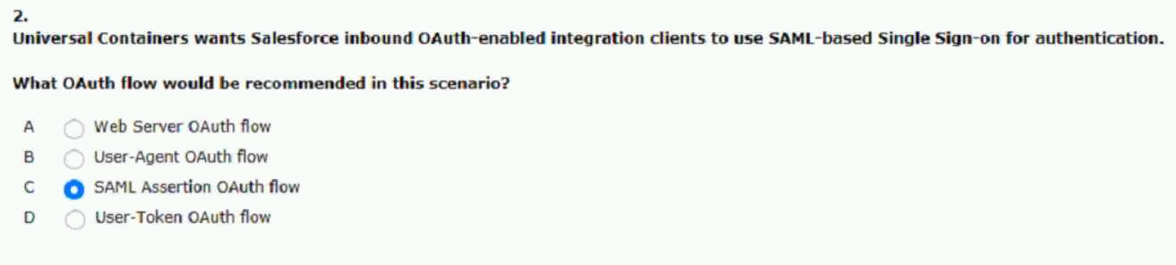
3.seamless access to the partner community.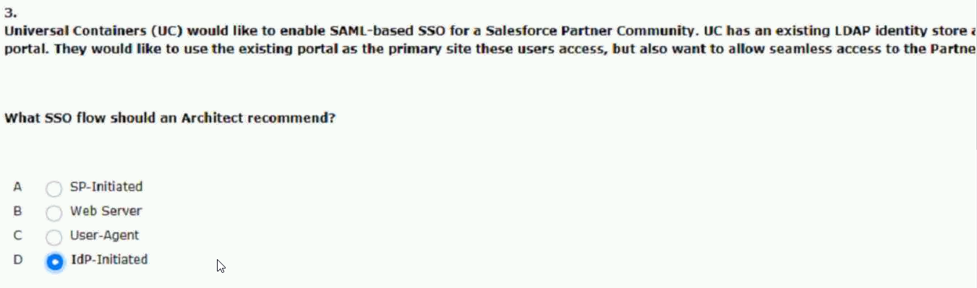
4.accessible to salesforce for the creation of accounts.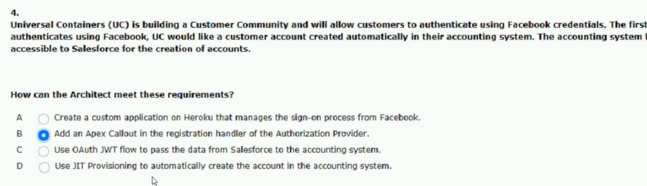
5.only when not connected to an internal company network?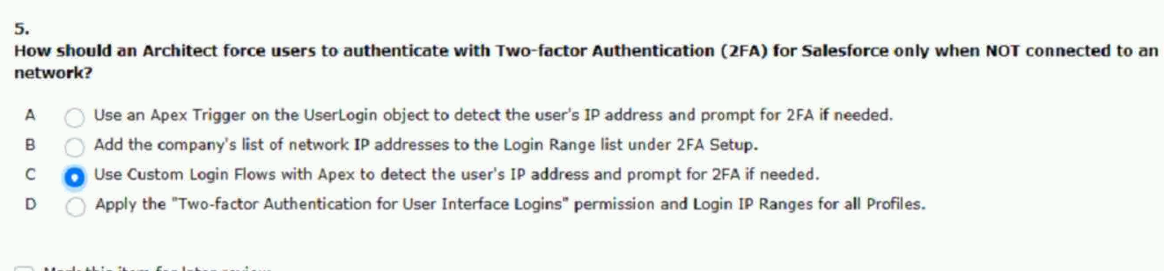

7.into account when using digital certificates.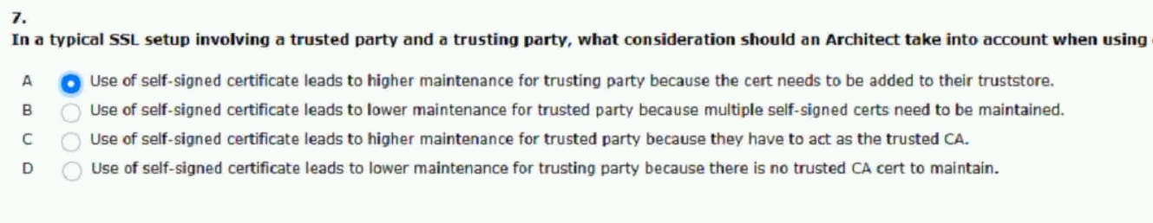
8.is used for accessing the salesforce mobile app.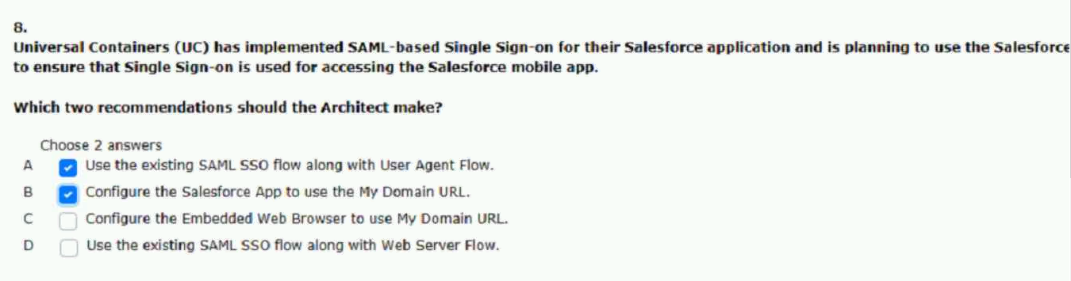
9.flow for authentication purposes.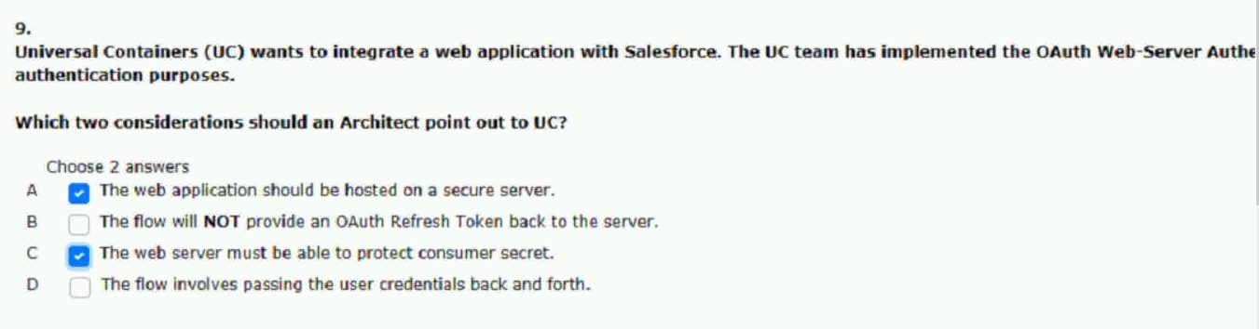
10.see where refresh tokens can be applied.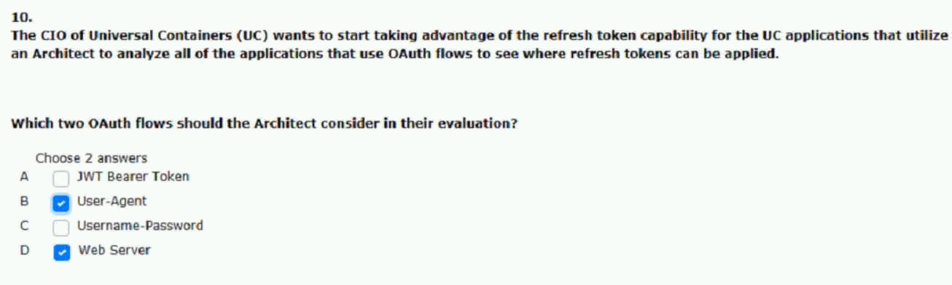
11.adequate authentication solution for the third-party app.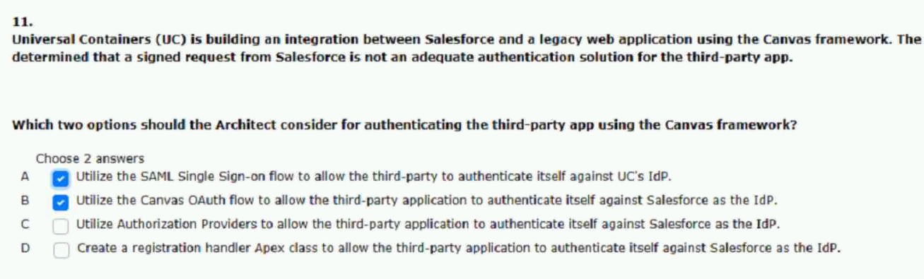
12. org after that employee had been terminated.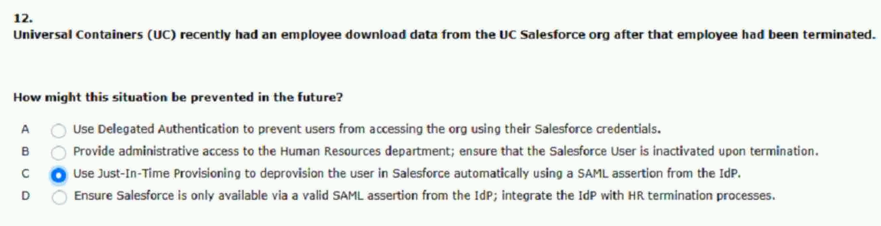
13.two-factor login process for it as well.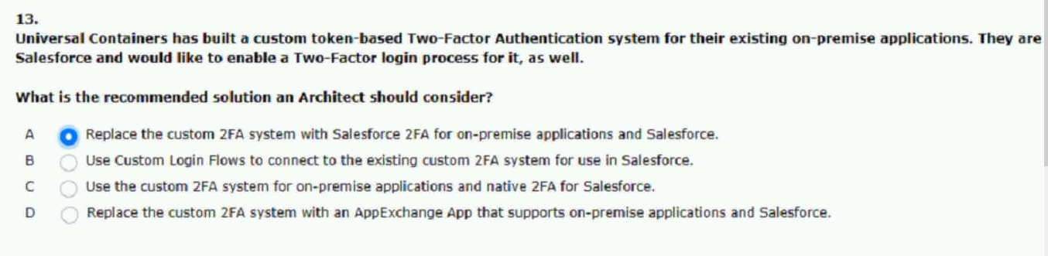
14.a delegated authentication implementation?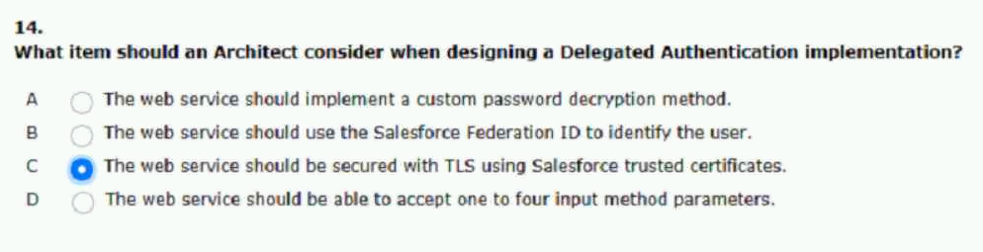

15.the following error message: “failed: not approved.
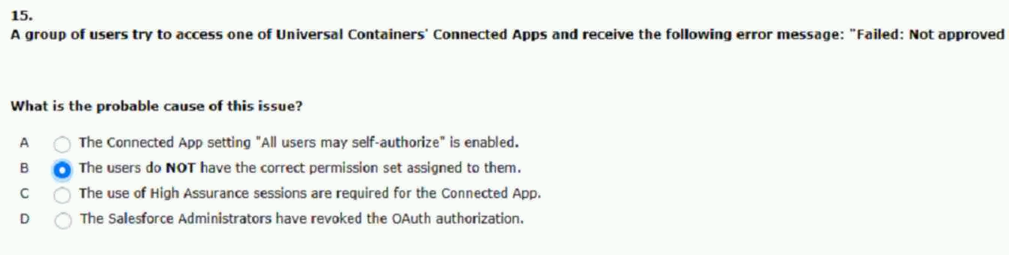

16.user using oauth username-password flow for the connection.
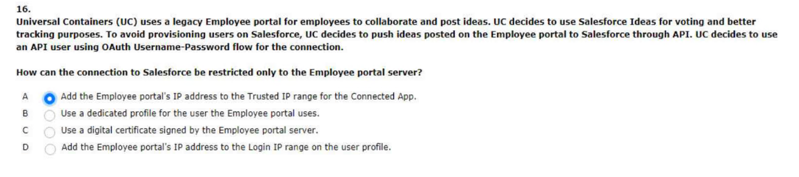
17.existing REST-ful API capable of managing users.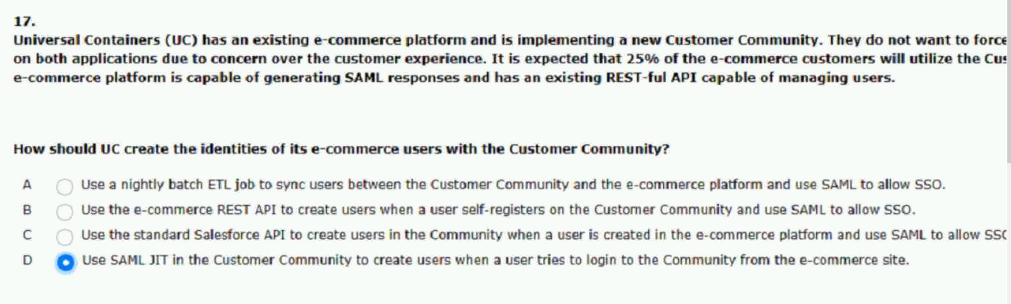
18.password to authenticate to this application.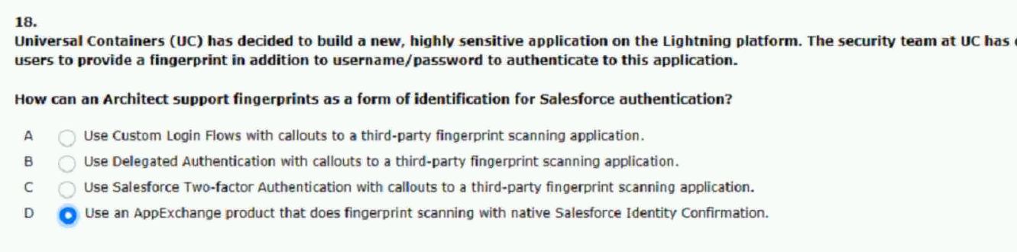
19.a single sign-on setup using SAML?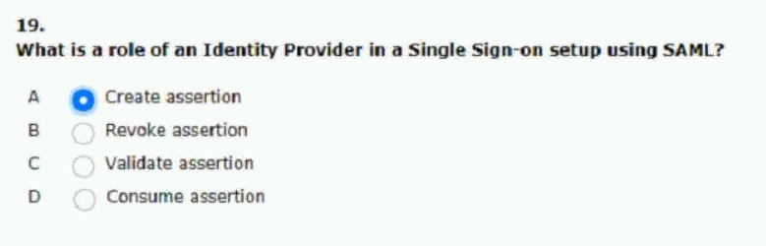
20.application and salesforce should be seamless.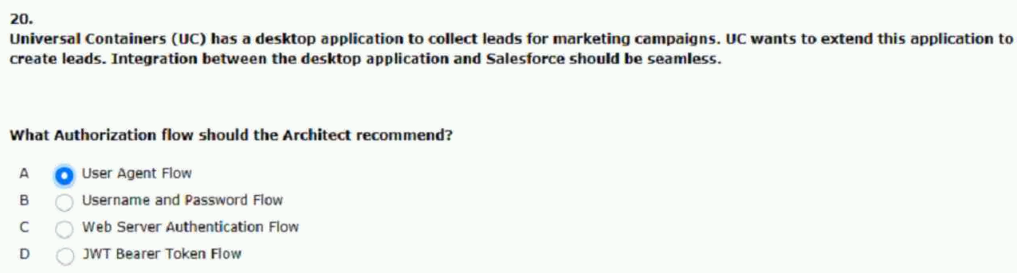
21.provide during the registration process.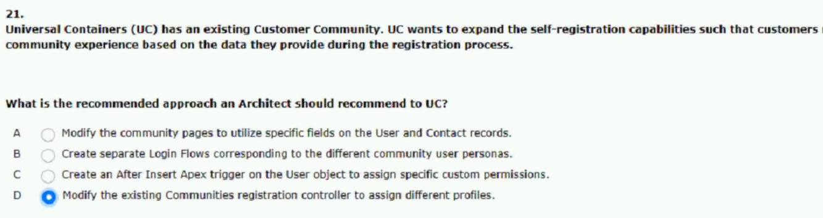
22.from their main salesforce org seamlessly.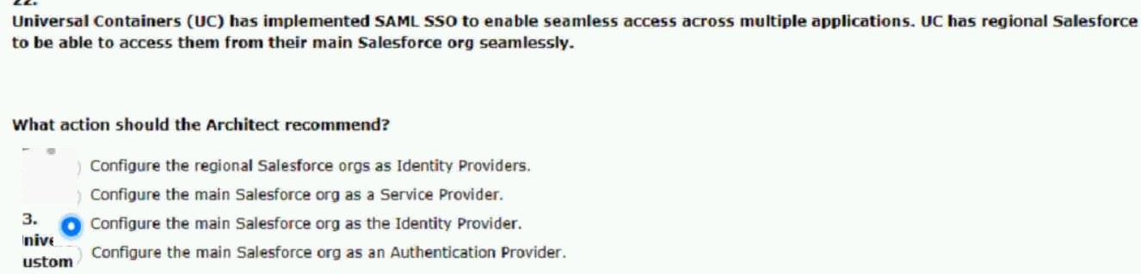
23.use identity connect in their current environment.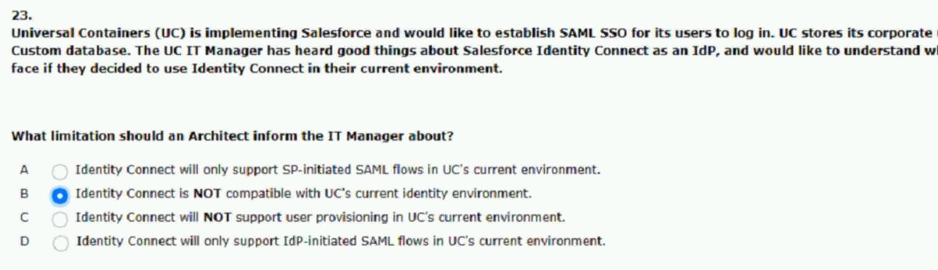

24.of their critical systems including salesforce.
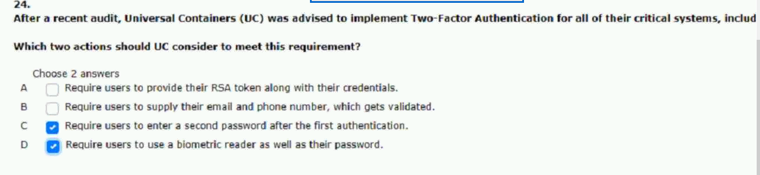
25.are not getting synched to the third-party system.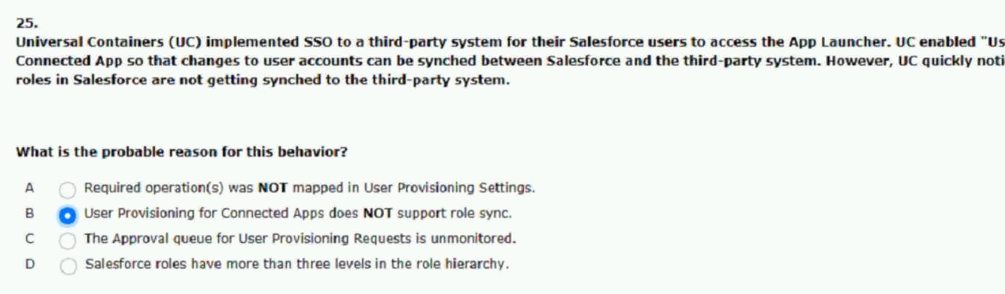
26.consuming licenses and adding dirty data.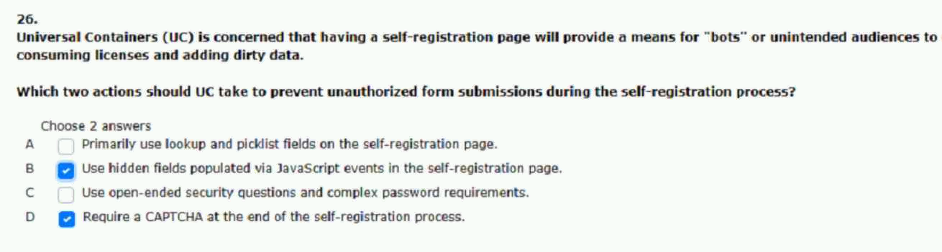
27.to the intended resource after authentication?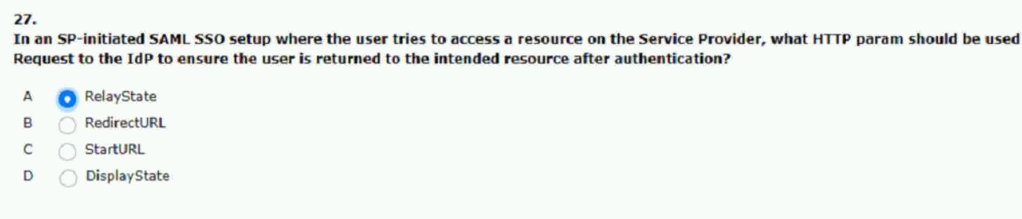
28.between salesforce and an external system?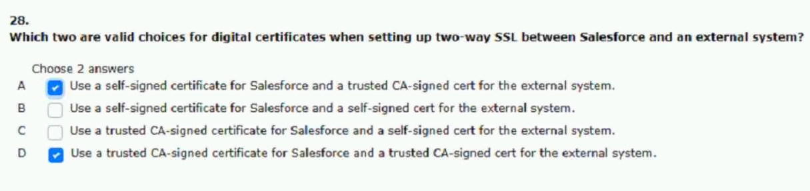
29.presented with the relevant pages.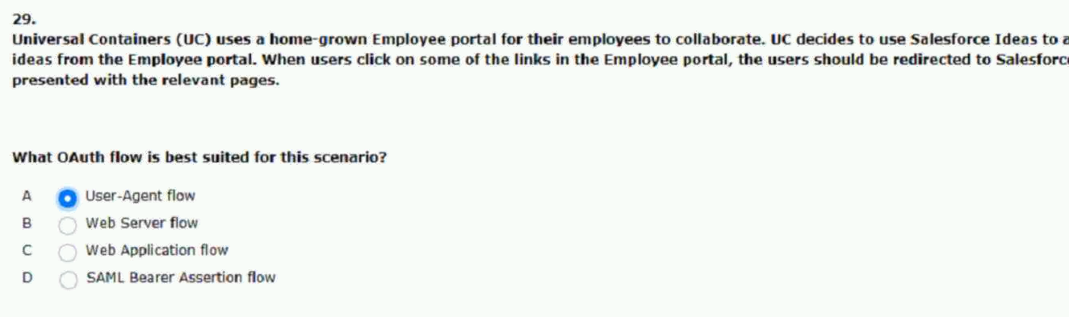

30. Architect receives a SAML error.
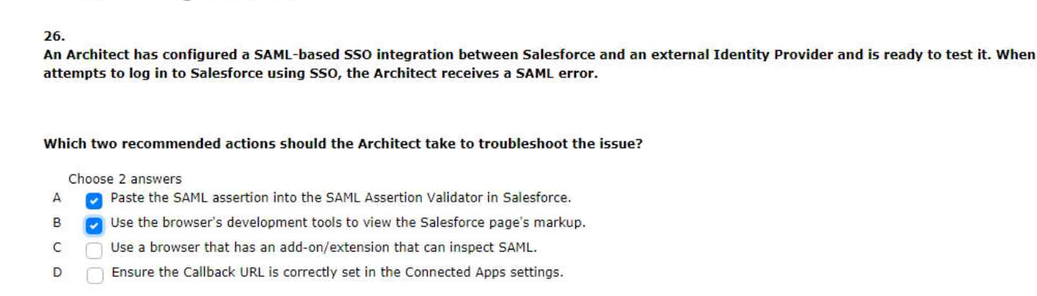
authenticated and presented with relevant pages.
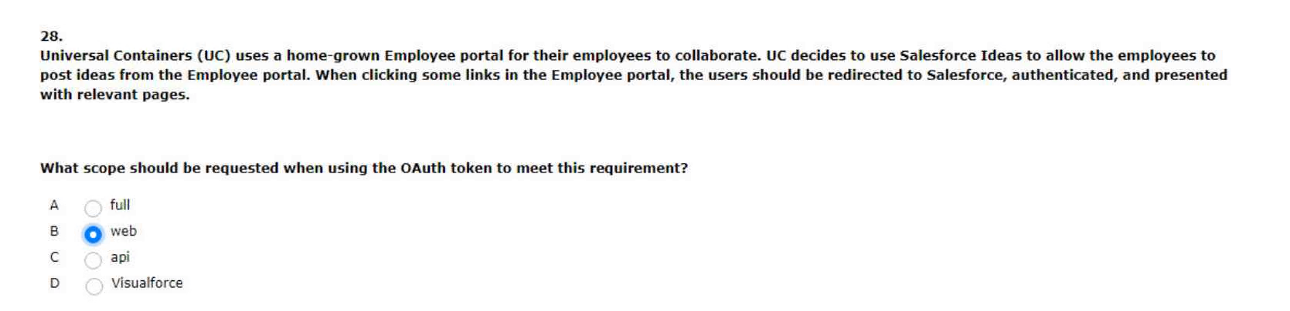

the appropriate profile and account values.
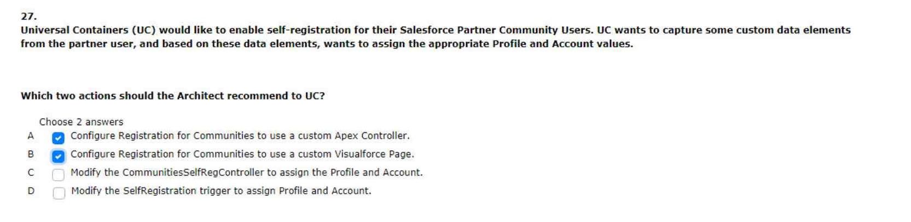

30.cpq system depending on their job position.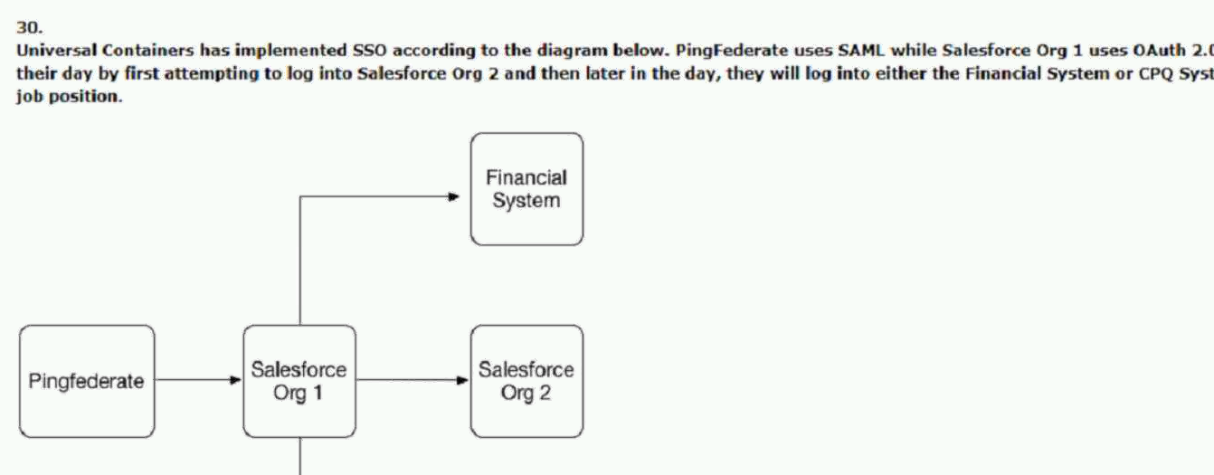
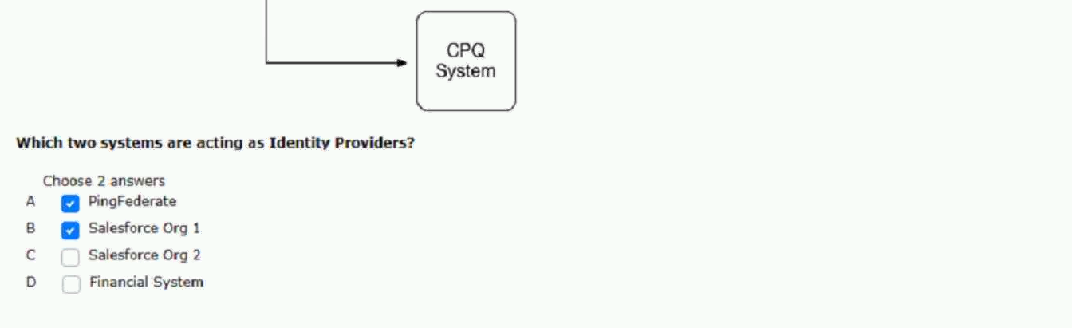
31.app and make it accessible from any location.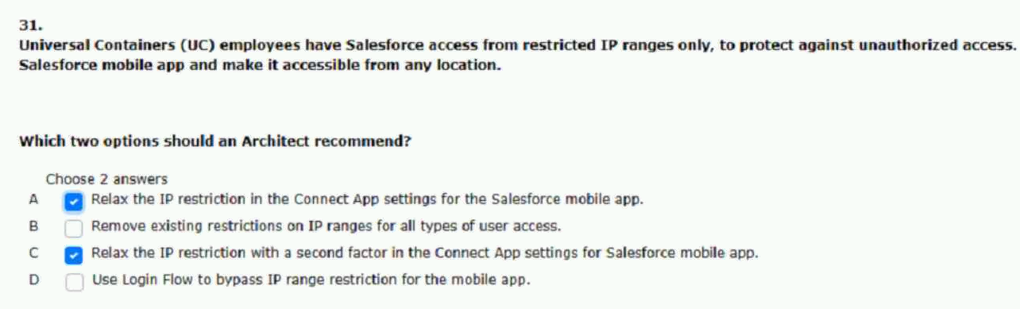

33.login option for a salesforce customer community.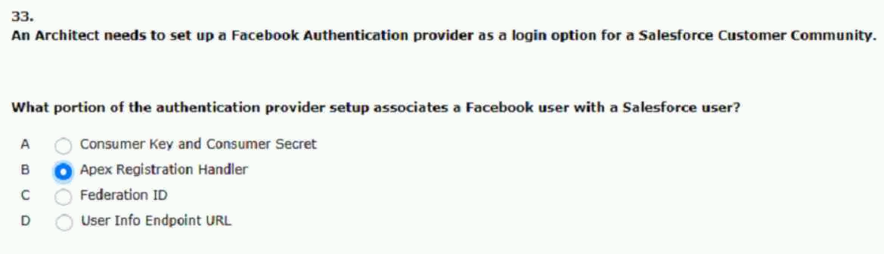

34.requirement that username be stored in any UC system.
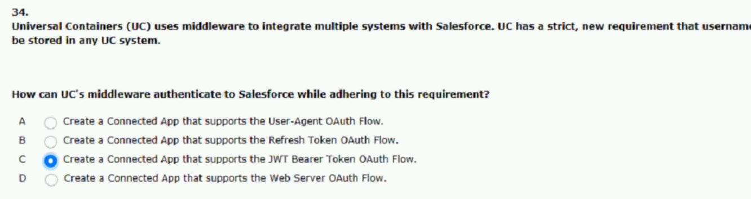
35.universal containers (UC) would like to enable.
assigment of profile roles and groups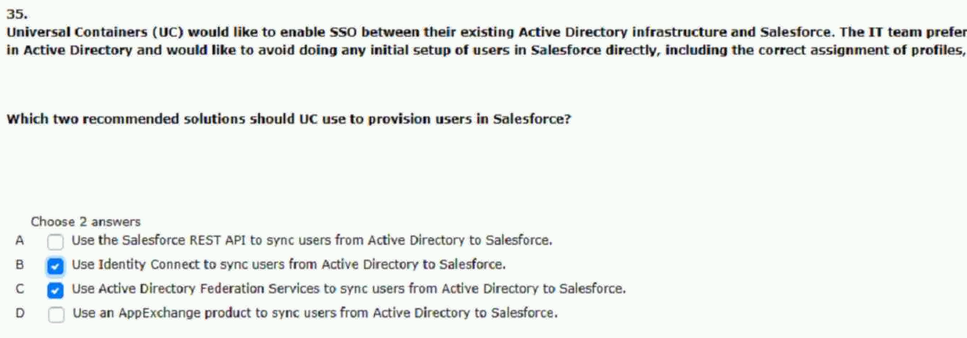
36.reduce administrative burden.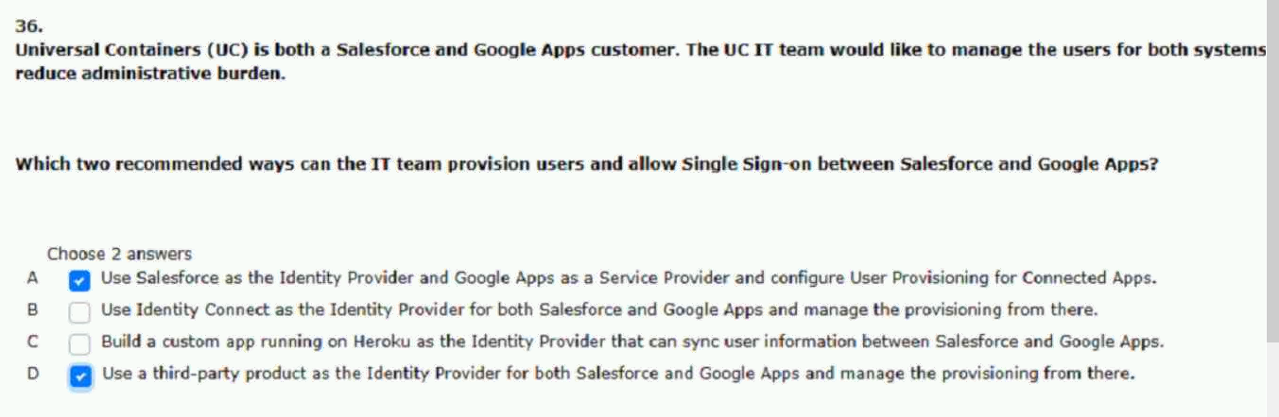
37.message when accessing the other orgs.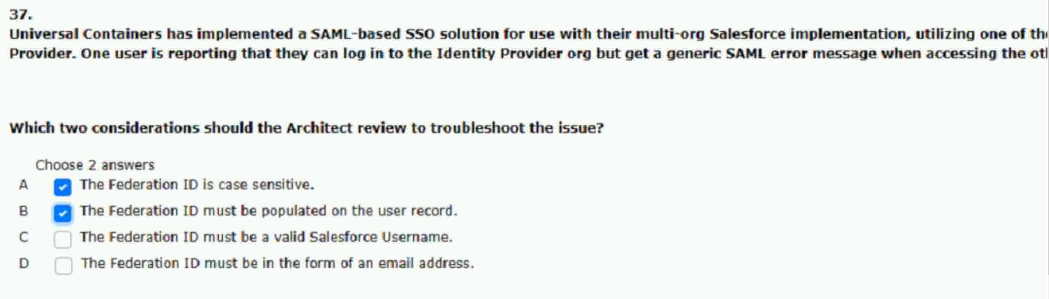
38.the login service and salesforce.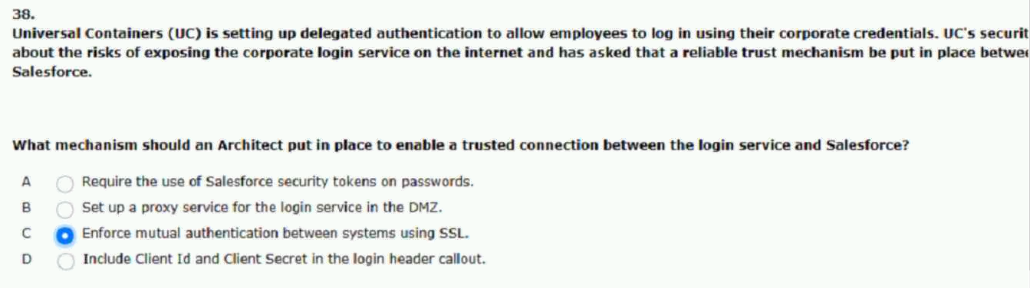
39.the architect receives a SAML error.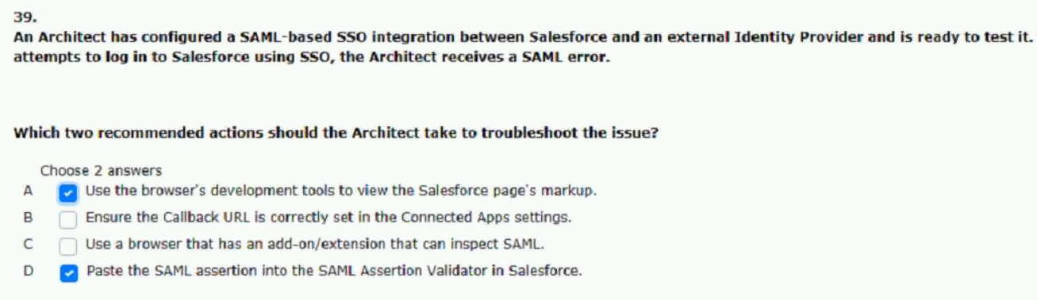
40.credentials to authenticate to the community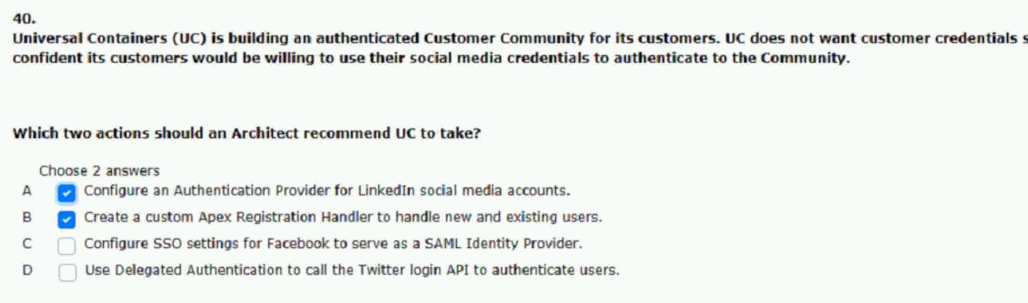
41.branding for their partner community users.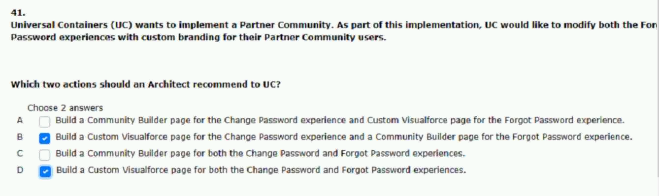
42.authentication solution help guard against.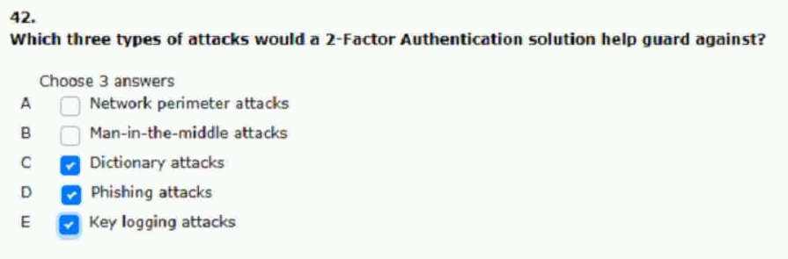
43.external identity provider and corporate identity store.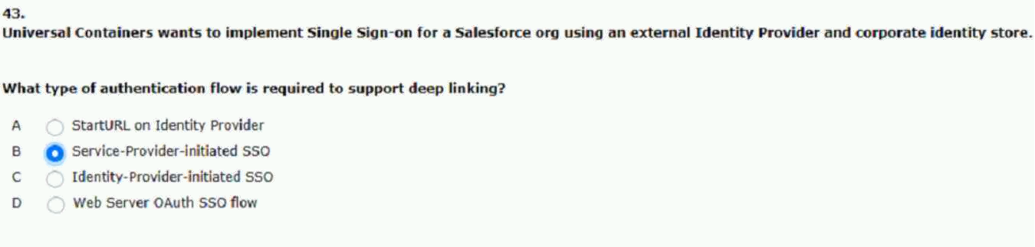
44.uc will utilize a third-party idp using SAML SSO.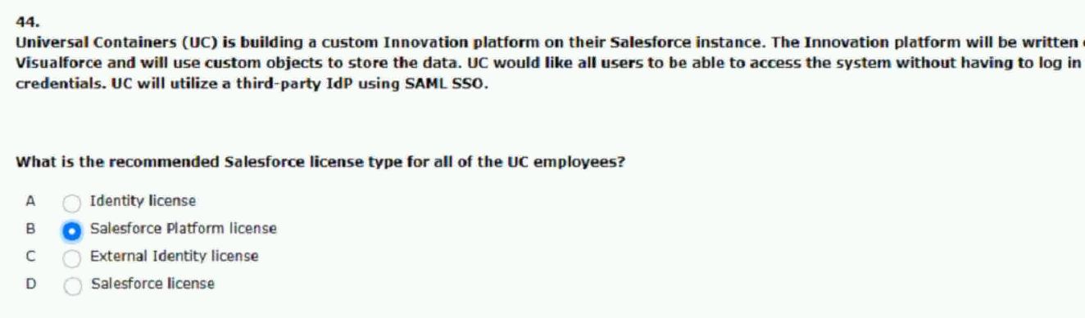
45.apps that are available to individual users.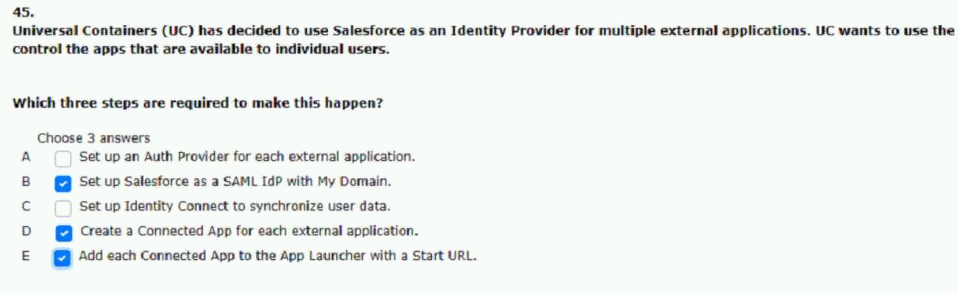

46.use ad credentials or salesforce credentials.
logged in with salesforce credentials?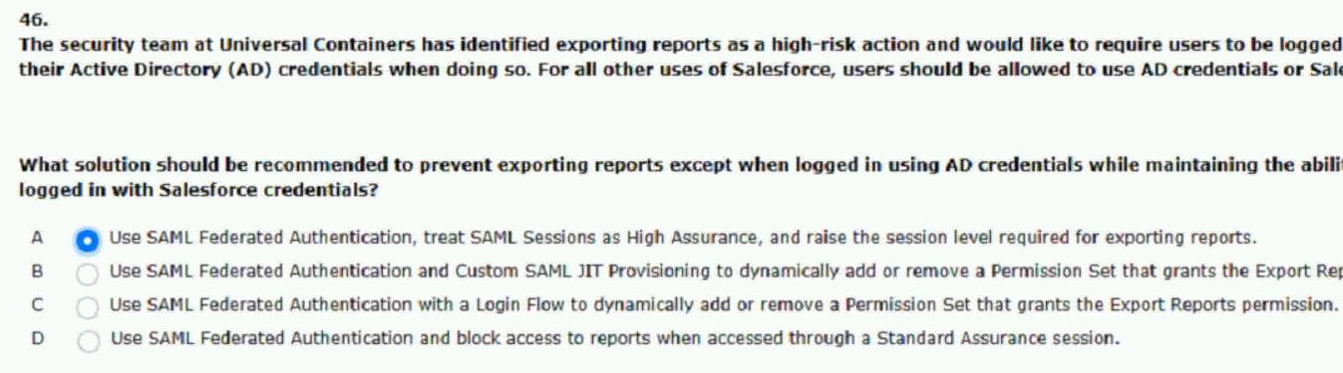
47.portal connects to salesforce using Oauth.
specific idea after authentication.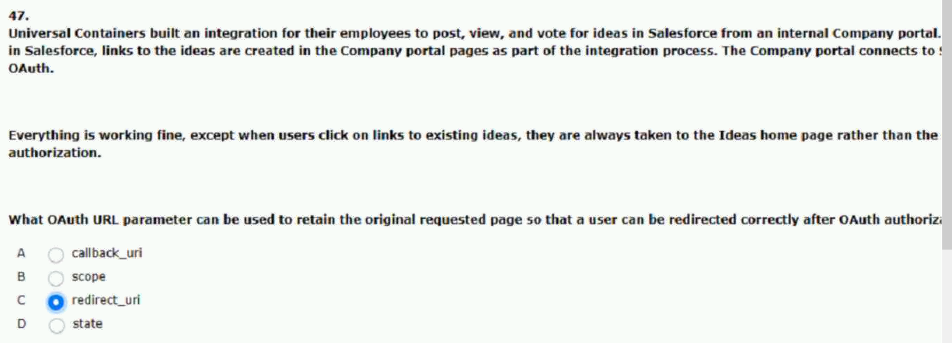
48.javascript code or libraries to the application.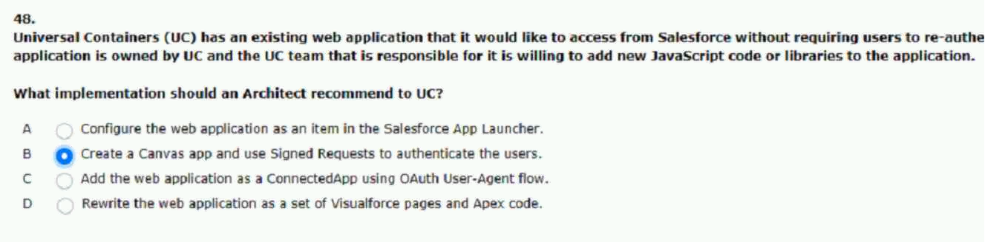
49.groups to help configure salesforce users.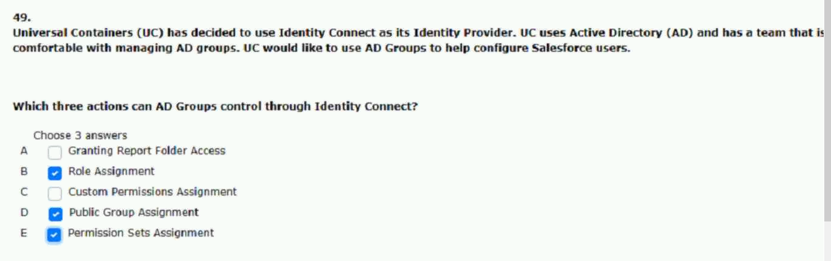
50.dashboards to keep track of regional shipping KPIs.
same approach for the GS users as well.
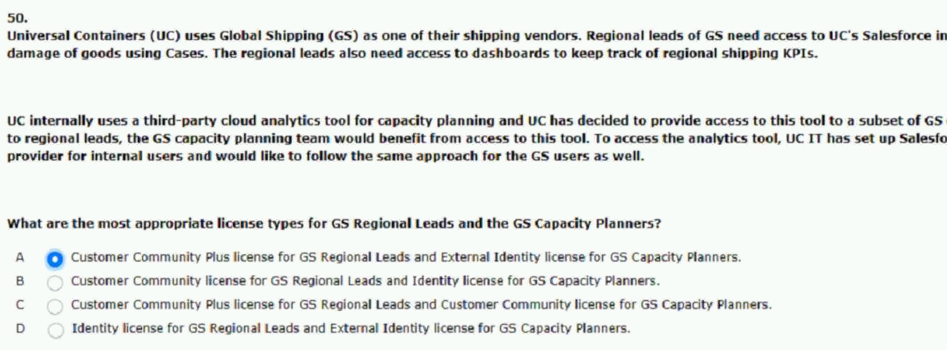
51.enter credentials every time they use the app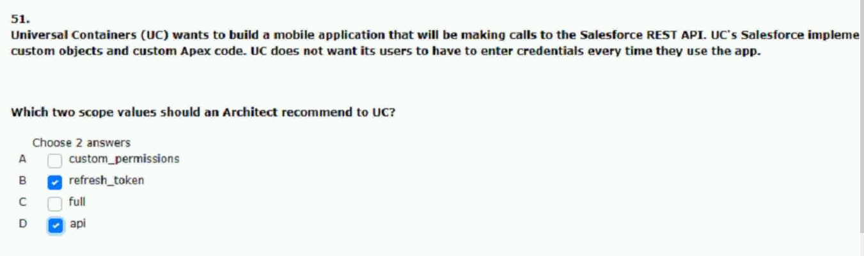
52.with salesforce ideas through the api.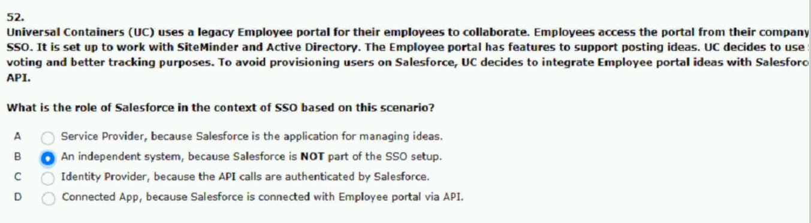
53.minimize the administration overhead.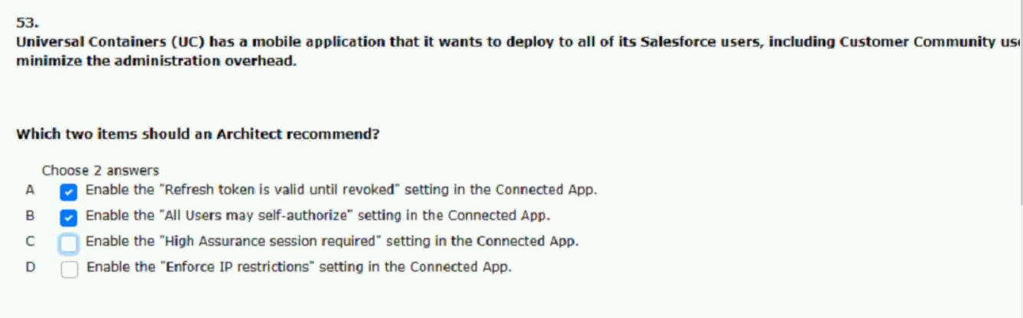
54.federated single sign-on solutions?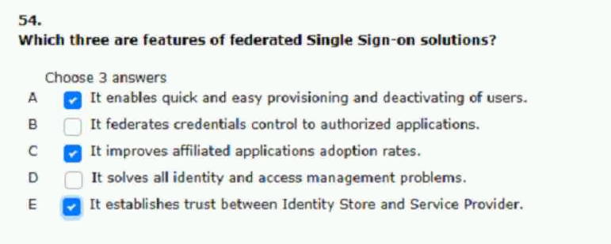
55.web services be REST-ful and written in .net.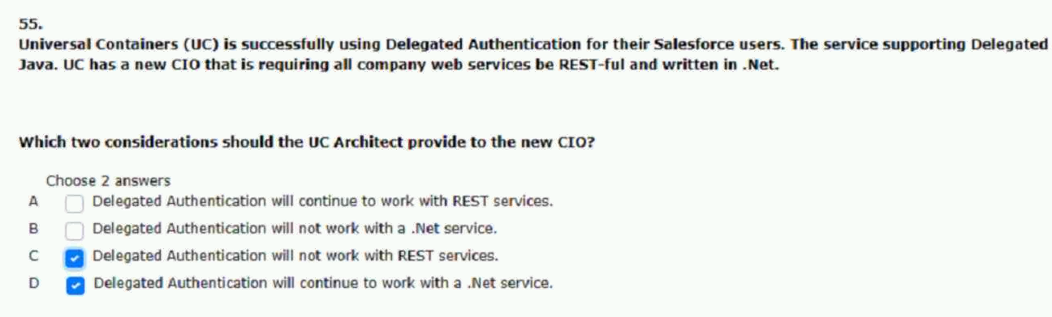
56.to properly secure access to the app.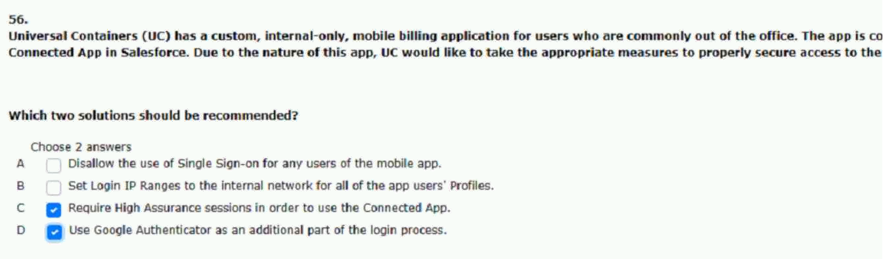
57.instead of being shown the idP login page.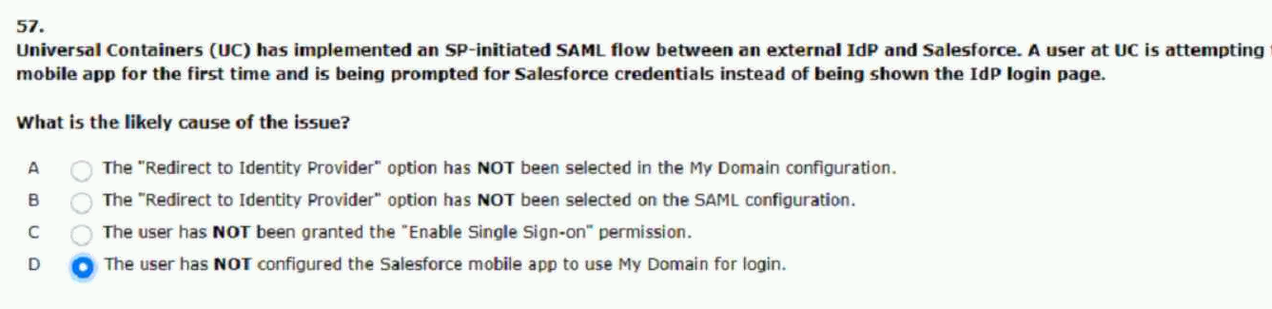

59.resources mobile users can access.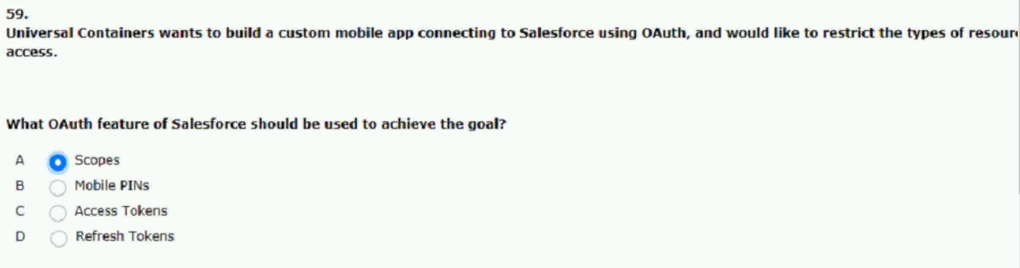
60.differentiate salesforce from other service providers.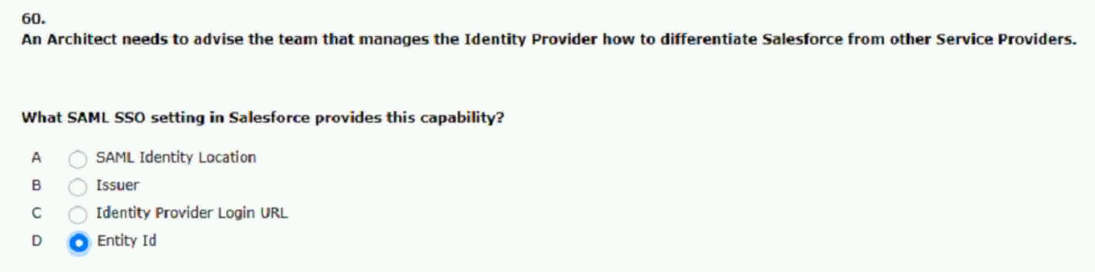

61.for their critical systems including salesforce? (set-2)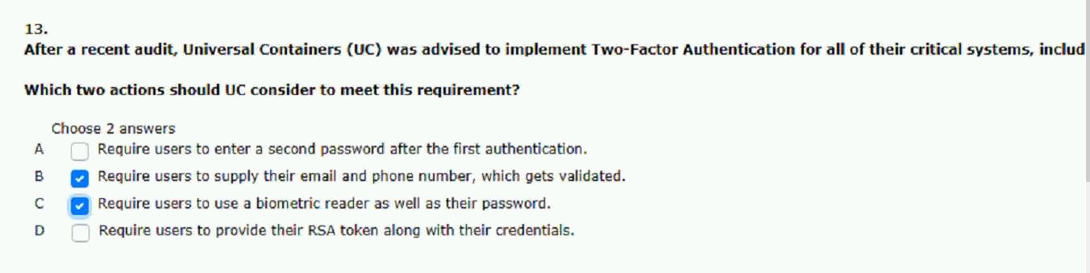
62.username-possword flow for the connection. (set-2)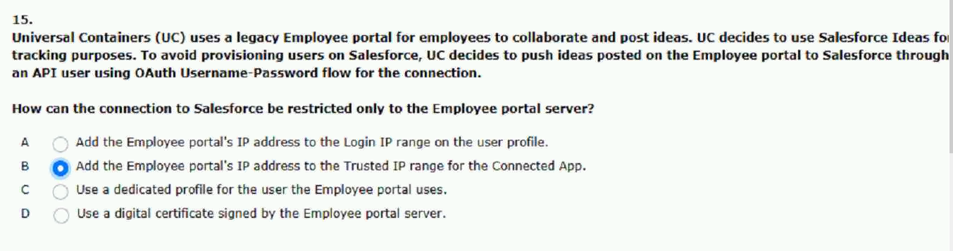
63.correct assignment of profiles roles and groups. (set-2)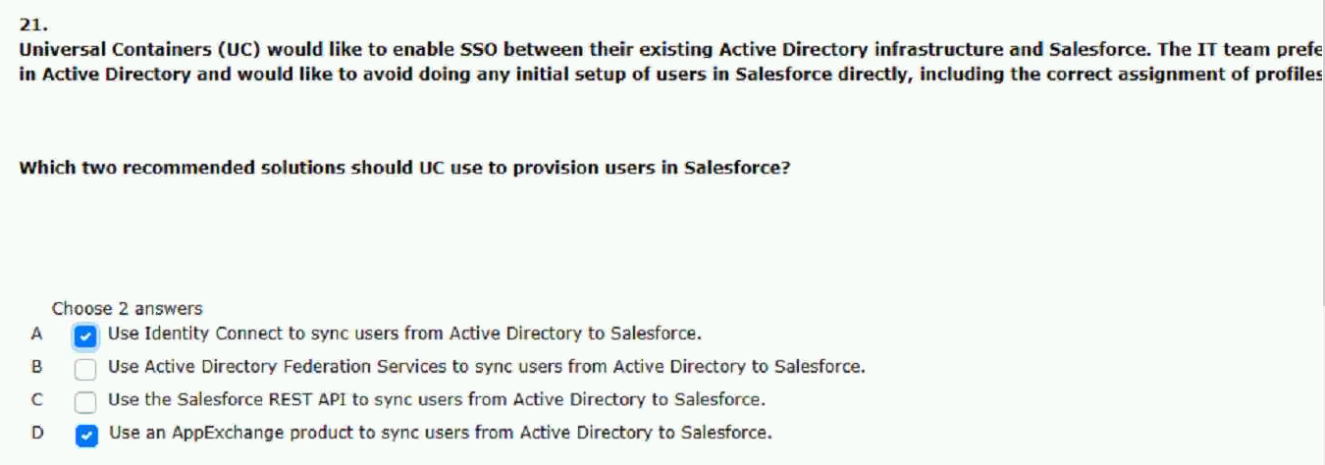
64.the architect receives a saml error. (set-2)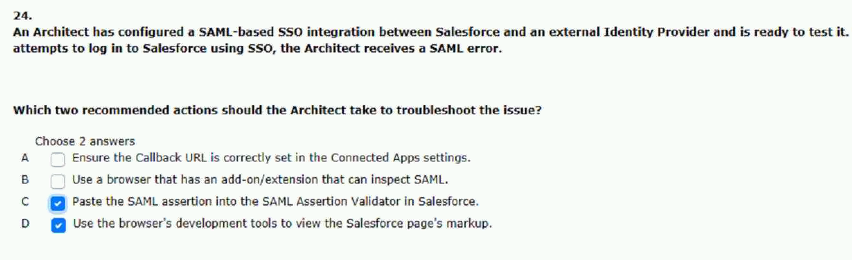
65.the company portal connects to salesforce using Oauth. (set-2)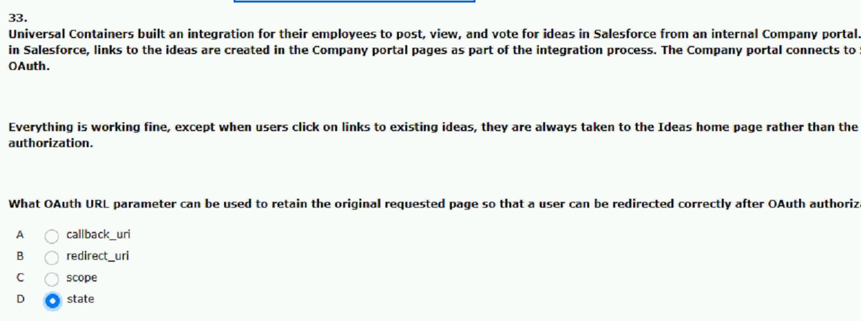
66.presented with the relevant pages. (set-2)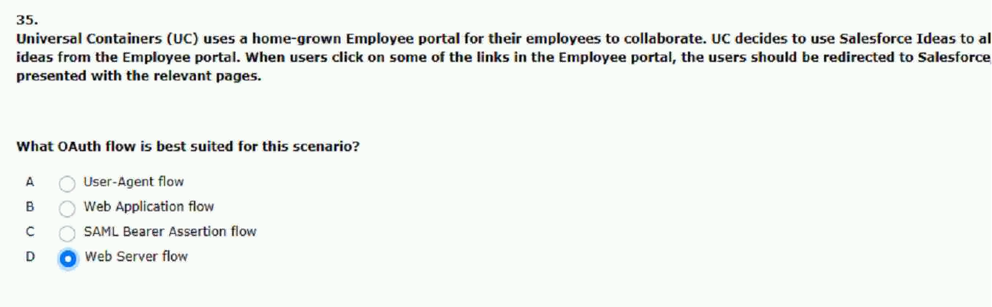
67.a two-factor login process for it as well. (set-2)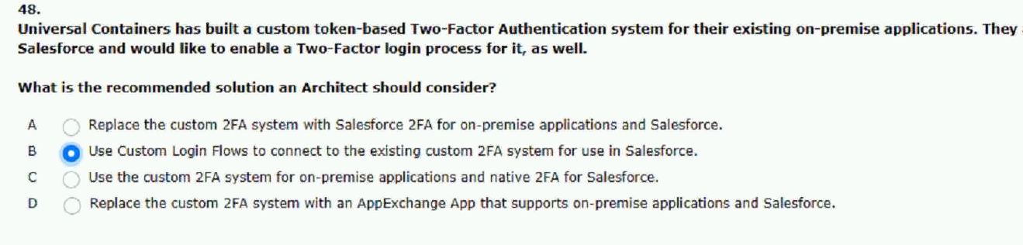
68.possword to authenticate to this application. (set-2)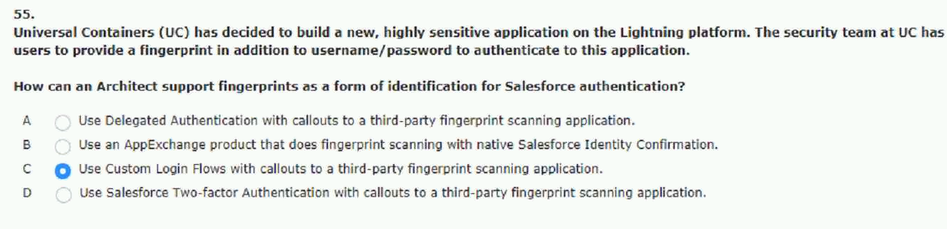
2. will be authenticated to a specific user.
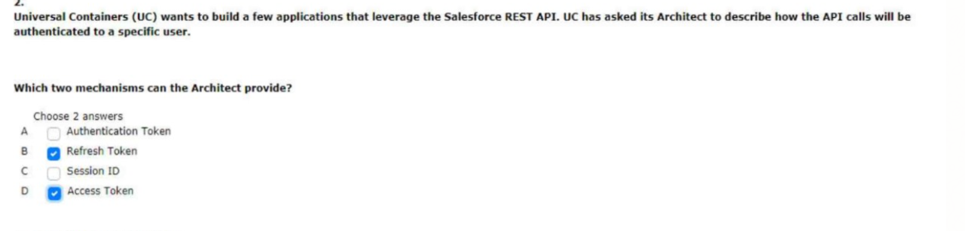

3. authentication using digital certificates
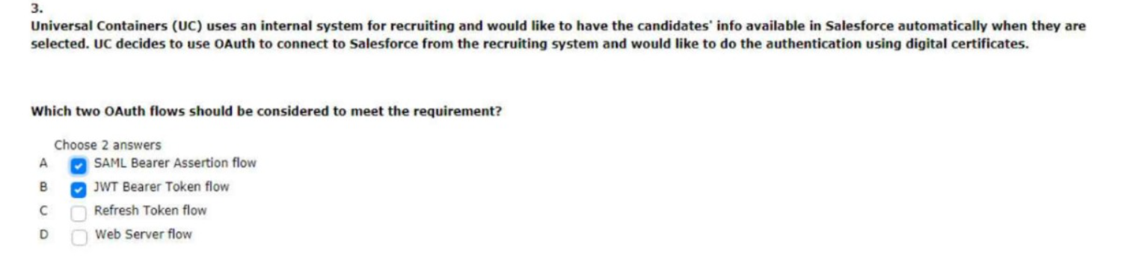

in sp-initialted single sign-on
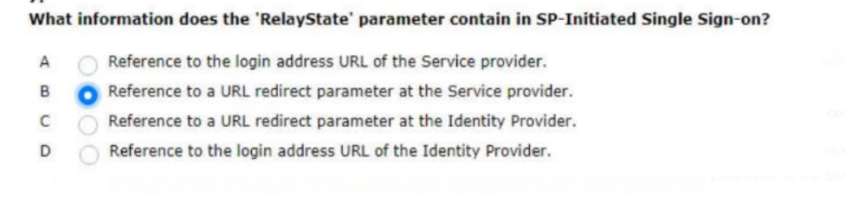
8. bookmarked link to my Domain URL
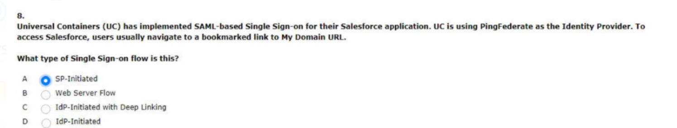

for all of their identity and access management needs
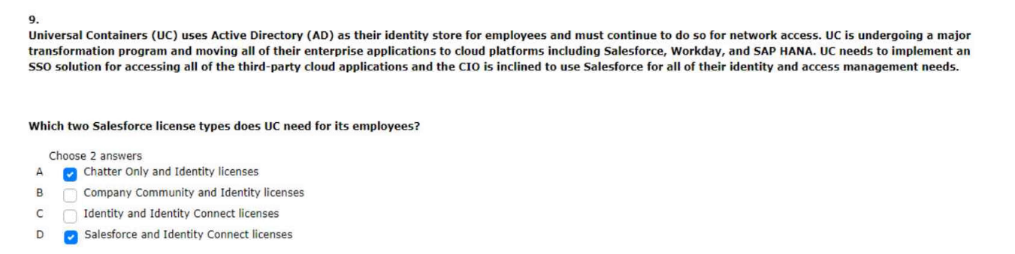
the mobile access needs to be restricted to only the sales team
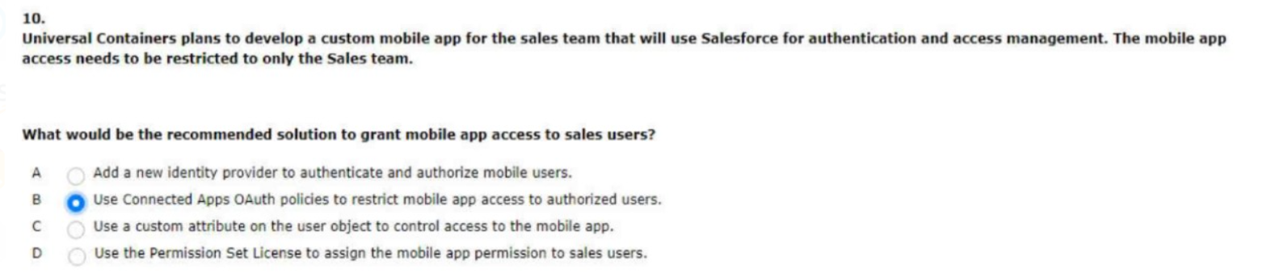

architect brought in to assist with the implementation
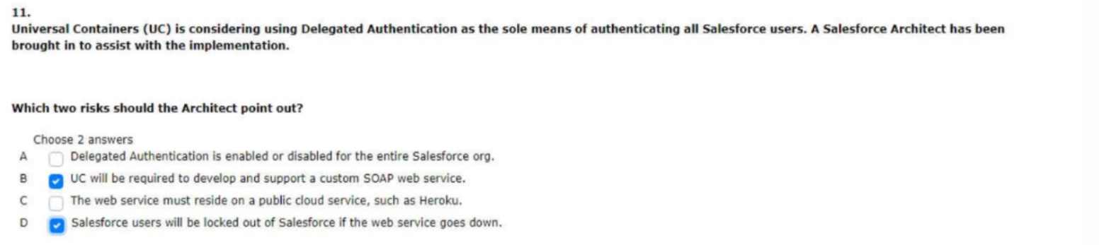

for a certain subset of salesforce users
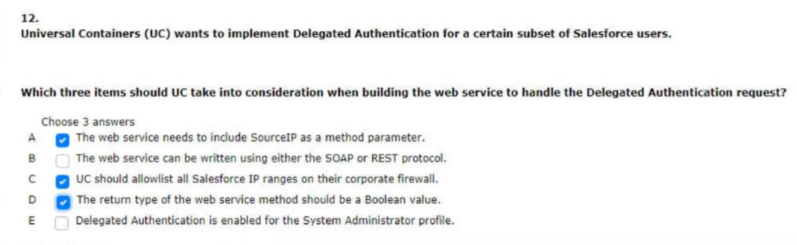
which irg and credentials are tied to which business process
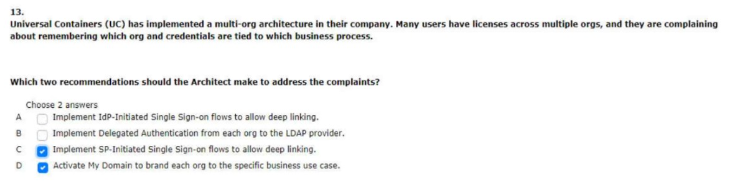
uc would also like to have users in salesforce created on the fly if they provide accurate mainframe credentials
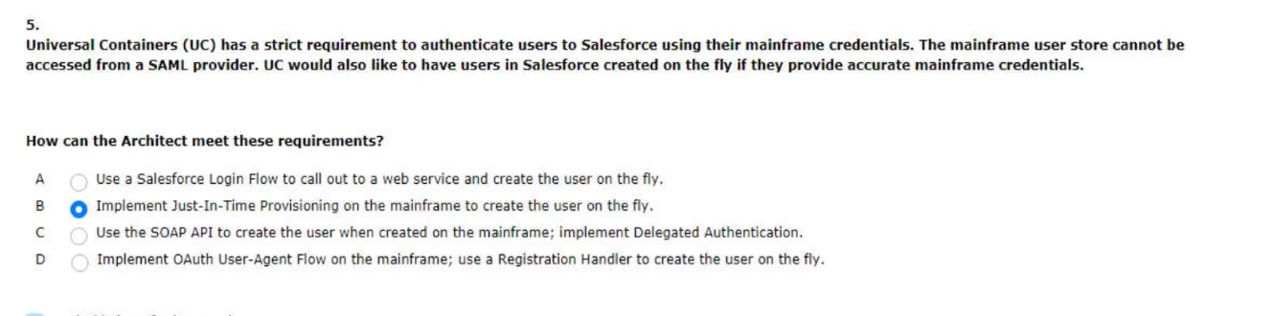

upon opening the mobile app without being prompted to log in again
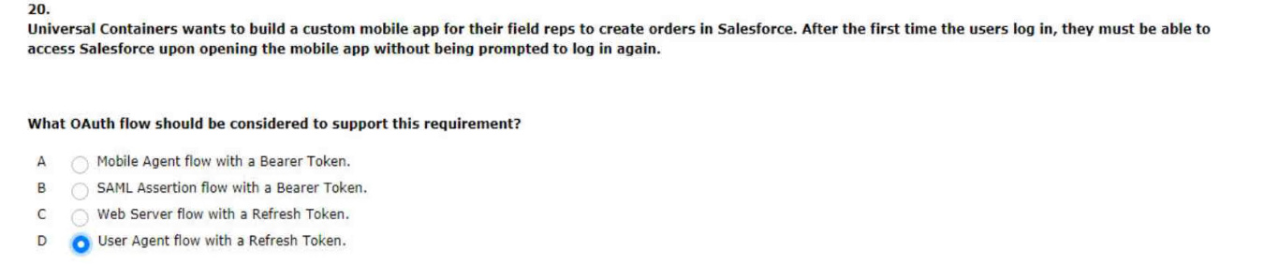

and would like to restrict the type of resources mobile users can access
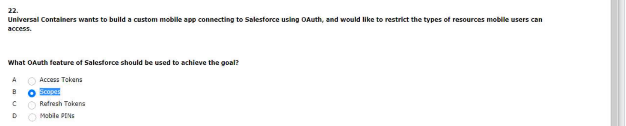
orgs financial system is the sso implementation landscape
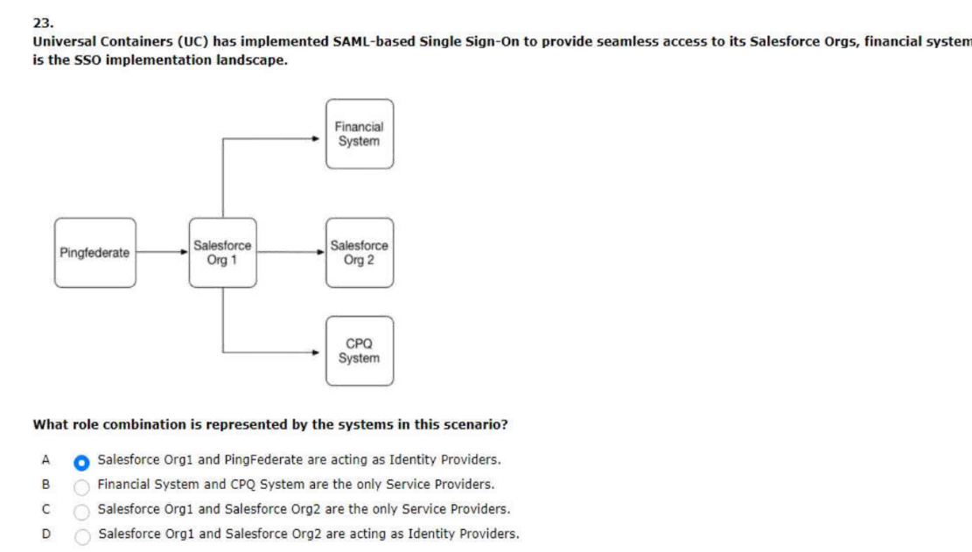
changed the uri scheme associated with the mobile app
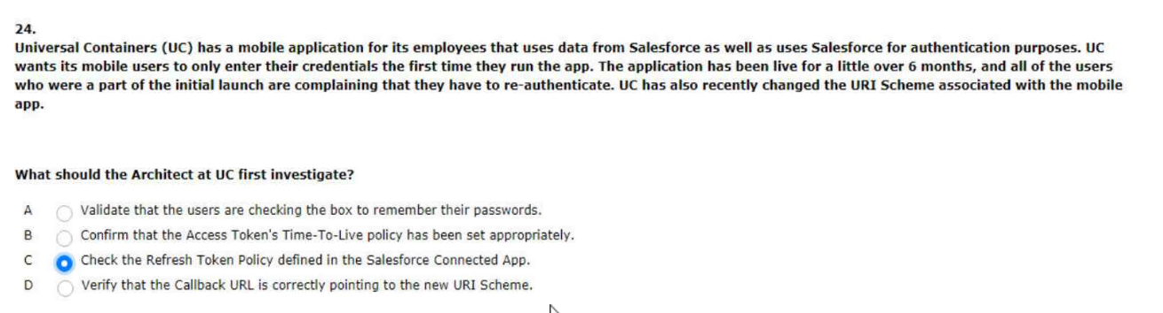

that all of the salesforce sso settings are correct
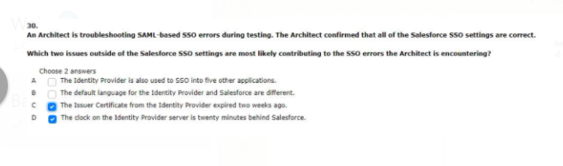

they are uncomfortable with the idea if an account record
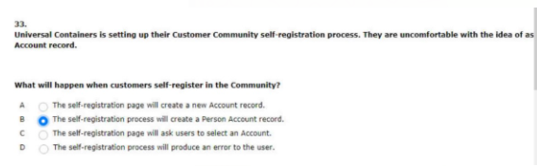

three capabilities does saml-based federated authentication provide?
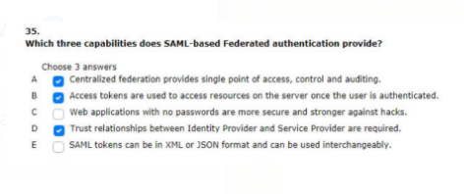
and ad assign the appropriate profile and permission sets based on ad group membership
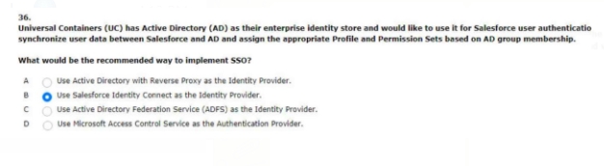
which two statements are capabilities of identity connect
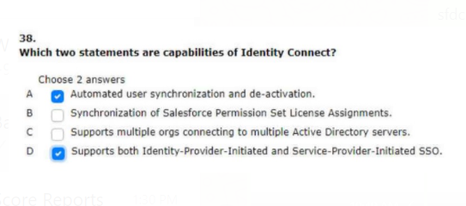

two capabilities does my domain enable in the context of a saml sso configuration
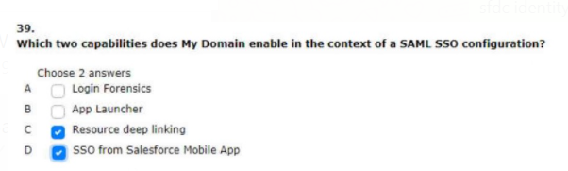
use the same set of credentials to access each of the applications
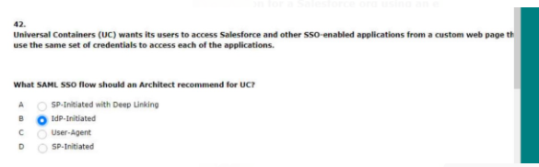
an external identity provides and corporate identity store

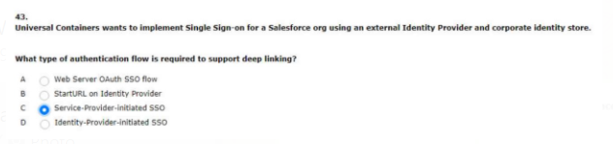

group of users to access external application from salesforce through app launcher
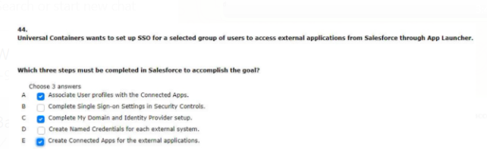

set up sso for a selected group of users to access external application from salesforce through app launcher
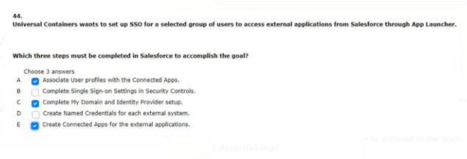
reflected on the appropriate customer community user
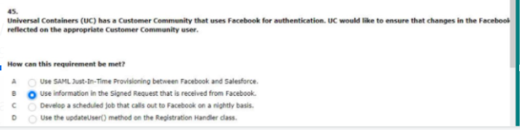

they can use the same idp for the new org
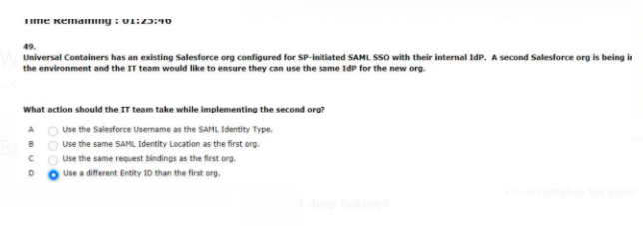

general and has enlisted an architect for advice
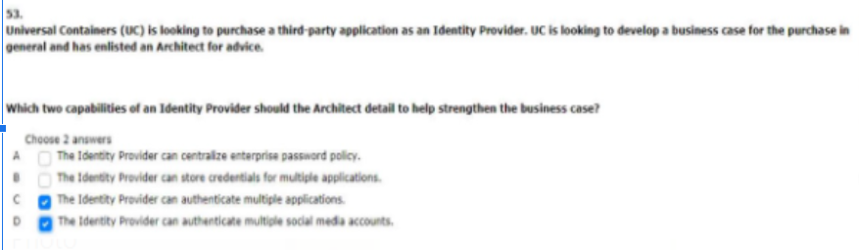

and would like to centralize the management of their salesforce user profiles
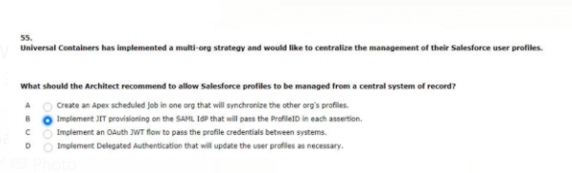
scams targeting its users and wants to add additional layers of login protection
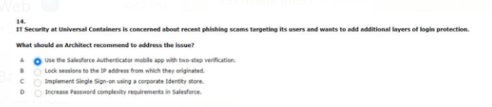
which two consideration should be made when implementing delegated authentication
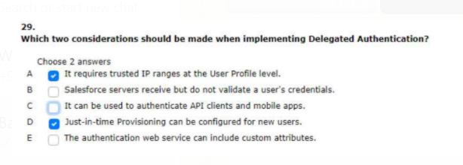

integration between the desktop application and salesforce should be seamless
